A+ Computer Science ANIMATED CAR

Lab Goal : This lab was designed to teach you how to use if statements.

Lab Description : Draw some type of car on the screen and then move that car across the screen over and over again.
Files Needed ::
GraphicsRunner.java
AnimatedCar.java

Sample Output :

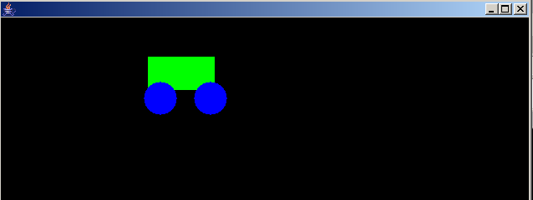
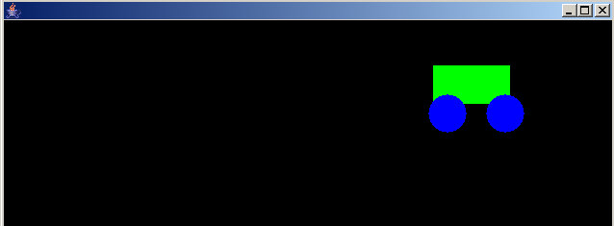
Your car has to move → across the screen.

